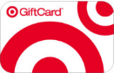
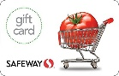
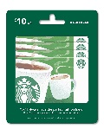
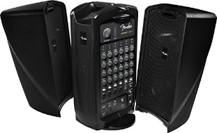
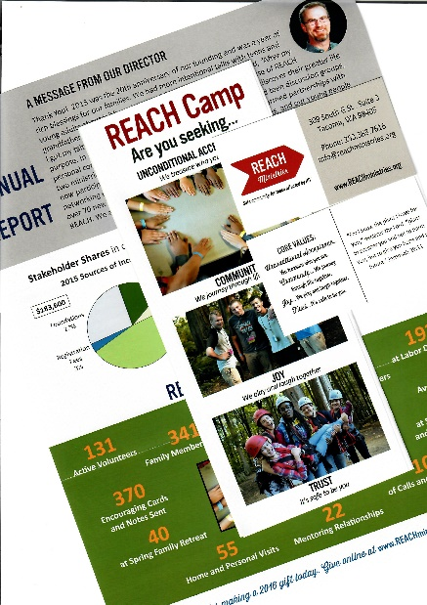
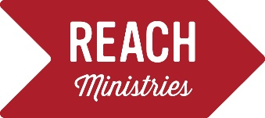
Safe community for those affected by HIV
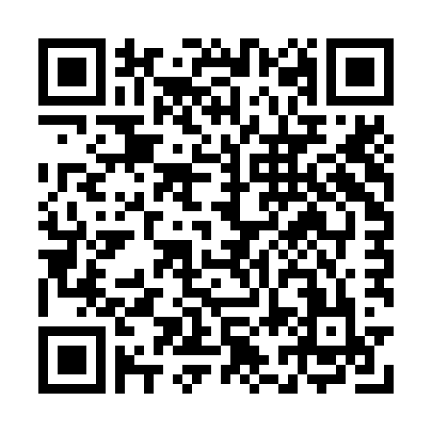
Check out our Amazon wish list for the items pictured here.
Scan QR code or type: a.co/3Tghlp5 into your browser window.
Or click here: Amazon REACH Wish List
REACH WISH LIST
- Club Med needs new storage drawers.

As everyone checks in for Camp, they bring their medications to our medical center called “Club Med”. Volunteers, too, check in with their pills, including vitamins, to “Doc Holiday”. It “normalizes” the routine when campers see that other people, even their counselors, take meds on a daily basis. REACH is all about showing kids that they are not alone in their experiences. Three storage drawers are needed for REACH Camp 2018.

- Portable sound system
A highpoint at REACH events is when all of us get together for group games.
We need a microphone so everyone knows how to play the game!
This PA system comes highly recommended, to suit our needs.

- Gift cards
Gift cards are a perfect way for REACH to thank volunteers, and send Christmas cheer to each of our families. Small denominations of $5-10 for Starbucks, and $10 and up for Target, Fred Meyer, and Safeway are favorites. Also, Amazon, Costco, and Office Depot cards in any amount help us buy supplies and snacks for our events. Please mail cards to: REACH Ministries, 309 South G Street, Suite 3, Tacoma, WA 98405.

- Graphic Services
Can you donate printing services? Our printing needs include quarterly newsletters, brochures, and business cards. At the top of our wish list is a vertical banner for our REACH info table. Let’s talk! Contact us: (253) 383-7616, or: info@REACHministries.org.

- Storage space
Our limited office space just can’t hold all the supplies we bring to REACH activities: the bins of sports equipment, art supplies, board games, decorations, and the drawers for Club Med, just to name a few. A climate controlled storage space would help us take care of all these things, in a safe and secure location.

